STUDENT ATTENDANCE SYSTEM
A student Attendance system has been conceptualized and implementing using RDBMS methodologies. The system is designed to efficiently to manage and track student attendance across various department.
The data has been stored in XML format for structured and transformed into a HTML table for web-based visualization. In the student attendance system, a table named “attendance1” has been created using datatypes to handle diverse data efficiently.
Create datatypes for student_id, name, email, phone and department
- CREATE TABLE students1( student_id INT AUTO_INCREMENT PRIMARY KEY, name VARCHAR(100)NOT NULL, email VARCHAR(100) NOT NULL UNIQUE, phone VARCHAR(15),department VARCHAR(50));
- Desc students1;

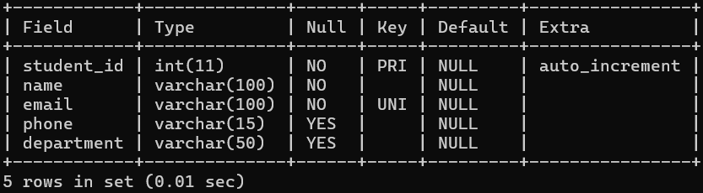
Records insertion:
- Insert into students values(1,’ramya’,’ramya123@gmail.com’,896489765,’cs’);
- Insert into students values(2,’priya’,’priya123@gmail.com’,896489765,’cs’);
- Insert into students values(3,’riya’,’riya123@gmail.com’,896489765,’cs’);
- Insert into students values(4,’ram’,’ram123@gmail.com’,896489765,’cs’);
- Insert into students values(5,’raj,’raj@gmail.com’,986489765,’cs’);
- Insert into students values(6,’mayy’,’mayy17@gmail.com’,896489765,’ise’);
- Insert into students values(7,’hamsa,’hvhamsa@gmail.com’,896489765,’cs’);
- Insert into students values(8,’aishu,’aishu123@gmail.com’,896489765,’’);
- Insert into students values(9,’xyz’,’xyz@gmail.com’,896489765,’cs’);
- Insert into students values(10,’rashmita’,reshmitagmail.com’,896489765,’cs’);
Select all rows from table students1

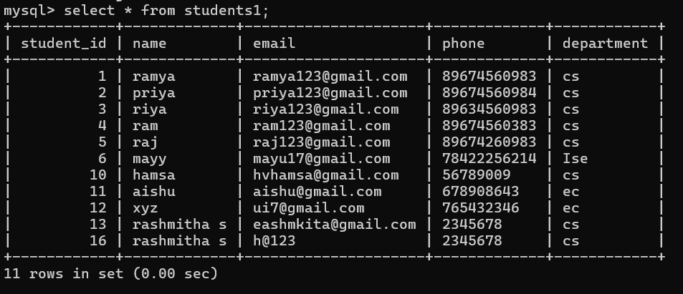
Create datatypes for attendance_id ,student_id ,date ,status
- CREATE TABLE attendance1 (id INT AUTO_INCREMENT PRIMARY KEY, student_id INT NOT NULL, attendance_date DATE NOT NULL, status ENUM('Present', 'Absent') NOT NULL, FOREIGN KEY (student_id) REFERENCES students1(student_id));
- Desc attendance1;

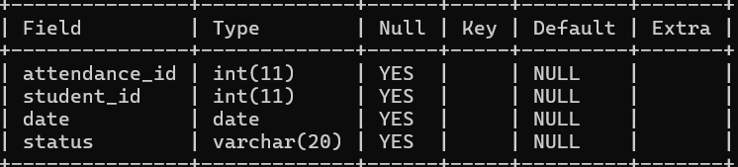
Records insertion:
- INSERT INTO Attendance VALUES (1, 1, '2023-11-24', 'Present');
- INSERT INTO Attendance VALUES (2, 2, '2023-11-24', 'Present');
- INSERT INTO Attendance VALUES (3, 3, '2023-11-24', 'absent');
- INSERT INTO Attendance VALUES (4, 4, '2023-11-24', 'absent');
- INSERT INTO Attendance VALUES (5, 5, '2023-11-24', 'present');
- INSERT INTO Attendance VALUES (6, 6, '2023-11-24', 'absent');
- INSERT INTO Attendance VALUES (7, 7, '2023-11-24', 'present');
- INSERT INTO Attendance VALUES (8, 8, '2023-11-24', 'present');
- INSERT INTO Attendance VALUES (9, 9, '2023-11-24', 'absent');
- INSERT INTO Attendance VALUES (10, 10, '2023-11-24', 'present');

- Select all rows from table attendence
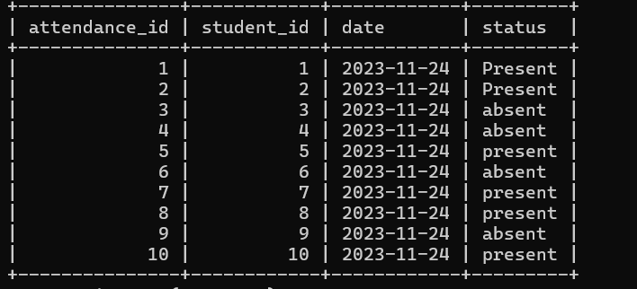

JOINS
- SELECT a.id, s.name AS student_name, a.attendance_date, a.status FROM attendance1 a JOIN students1 s ON a.student_id = s.student_id;

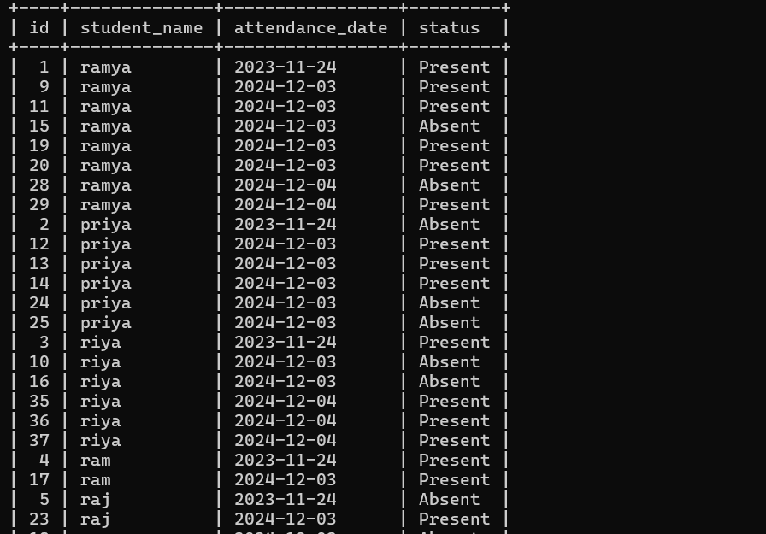
- SELECT s.name AS student_name, COUNT(CASE WHEN a.status = 'Present' THEN 1 END) AS present_days, COUNT(*) AS total_days, ROUND((COUNT(CASE WHEN a.status = 'Present' THEN 1 END) / COUNT(*)) * 100, 2) AS attendance_percentage FROM attendance1 a JOIN students1 s ON a.student_id = s.student_id GROUP BY s.student_id;



- DELIMITER $$
CREATE PROCEDURE CheckLowAttendancee()
BEGIN
DECLARE done INT DEFAULT FALSE;
DECLARE student_name VARCHAR(100);
DECLARE attendance_percentage FLOAT;
DECLARE low_attendance_cursor CURSOR FOR
SELECT s.name, ROUND((COUNT(CASE WHEN a.status = 'Present' THEN 1 END) / COUNT(*)) * 100, 2) AS attendance_percentage FROM attendancec a JOIN studentss s ON a.student_id = s.student_id GROUP BY s.student_id HAVING attendance_percentage < 75;
DECLARE CONTINUE HANDLER FOR NOT FOUND SET done = TRUE;
OPEN low_attendance_cursor;
read_loop: LOOP
FETCH low_attendance_cursor INTO student_name, attendance_percentage;
IF done THEN
LEAVE read_loop;
END IF;
SELECT CONCAT('Alert: ', student_name, ' has low attendance: ', attendance_percentage, '%') AS message;
END LOOP;
CLOSE low_attendance_cursor;
END$$
DELIMITER ;
- select * from students1;
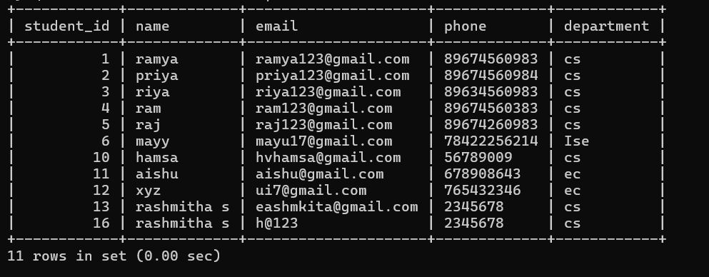
- CALL CheckLowAttendancee();
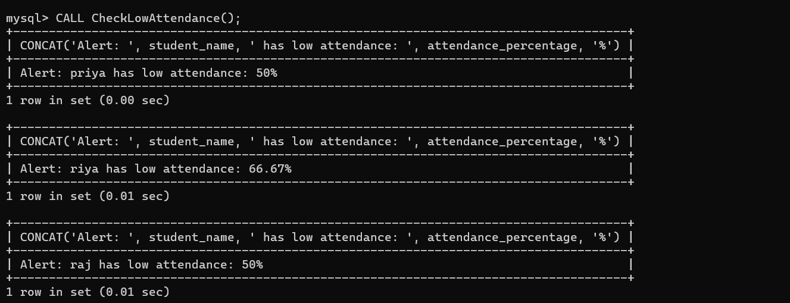
XML
<?xml vesion=”1.0” encoding=”UTF-8”??
<!DOCTYPE html>
<html lang="en">
<head>
<meta charset="UTF-8">
<meta name="viewport" content="width=device-width, initial-scale=1.0">
<title>Student Attendance System</title>
<link rel="stylesheet" href="style.css">
</head>
<body>
<div class="container">
<h2>Login</h2>
<form id="loginForm">
<label for="username">Username:</label>
<input type="text" id="username" required>

<label for="password">Password:</label>
<input type="password" id="password" required>

<button type="submit">Login</button>
</form>
</div>

<script src="app.js"></script>
</body>
</html>

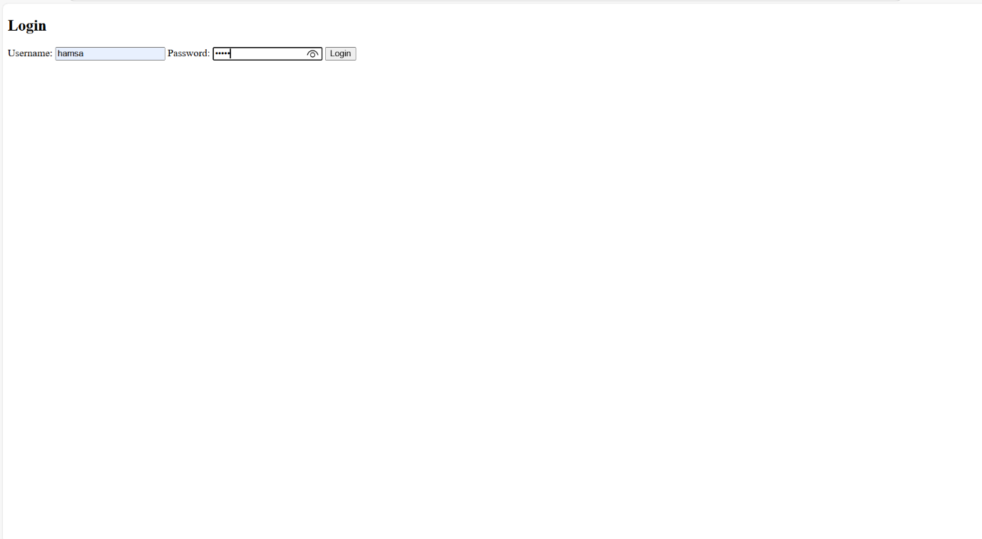
XML
<!DOCTYPE html>
<html lang="en">
<head>
<meta charset="UTF-8">
<meta name="viewport" content="width=device-width, initial-scale=1.0">
<title>Student Attendance System</title>
<style>
table, th, td {
border: 1px solid black;
border-collapse: collapse;
}
th, td {
padding: 8px;
text-align: center;
}
.alert {
color: red;
}
</style>
</head>
<body>
<h1>Student Attendance System</h1>
<h2>Mark Attendance</h2>
<form id="attendanceForm">
<label for="studentName">Student Name:</label>
<input type="text" id="studentName" required><br><br>
<label for="status">Status:</label>
<select id="status">
<option value="Present">Present</option>
<option value="Absent">Absent</option>
</select><br><br>

<button type="submit">Mark Attendance</button>
</form>
<br><br>
<h2>Attendance Report</h2>
<button onclick="generateReport()">Generate Report</button>
<div id="report"></div>
<br><br>
<h2>Attendance Records</h2>
<table id="attendanceTable">
<thead>
<tr>
<th>Student Name</th>
<th>Status</th>
<th>Date</th>
</tr>
</thead>
<tbody>
</tbody>
</table>
<script>
window.onload = function() {
displayAttendance();
};
document.getElementById('attendanceForm').addEventListener('submit', function(event) {
event.preventDefault();
const studentName = document.getElementById('studentName').value;
const status = document.getElementById('status').value;
const date = new Date().toLocaleDateString(); // Get current date
let attendanceData = JSON.parse(localStorage.getItem('attendance')) || [];
attendanceData.push({ studentName, status, date });
localStorage.setItem('attendance', JSON.stringify(attendanceData)); document.getElementById('attendanceForm').reset();
displayAttendance();
});
function displayAttendance() {
const attendanceData = JSON.parse(localStorage.getItem('attendance')) || [];
const tableBody = document.getElementById('attendanceTable').getElementsByTagName('tbody')[0];
tableBody.innerHTML = '';
attendanceData.forEach(record => {
const row = tableBody.insertRow();
const cell1 = row.insertCell(0);
const cell2 = row.insertCell(1);
const cell3 = row.insertCell(2);
cell1.textContent = record.studentName;
cell2.textContent = record.status;
cell3.textContent = record.date;
});
}
function generateReport() {
const attendanceData = JSON.parse(localStorage.getItem('attendance')) || [];
const studentAttendance = {};
attendanceData.forEach(record => {
if (!studentAttendance[record.studentName]) {
studentAttendance[record.studentName] = { present: 0, total: 0 };
}
studentAttendance[record.studentName].total++;
if (record.status === 'Present') {
studentAttendance[record.studentName].present++;
}
});
let reportHTML = '<h3>Attendance Summary:</h3>';
let lowAttendanceAlert = false;
for (let student in studentAttendance) {
const attendance = studentAttendance[student];
const attendancePercentage = (attendance.present / attendance.total) * 100;
reportHTML += `<p>${student}: ${attendance.present} Present, ${attendance.total} Total, ${attendancePercentage.toFixed(2)}% Attendance</p>`;
if (attendancePercentage < 75) {
reportHTML += `<p class="alert">${student} has low attendance!</p>`;
lowAttendanceAlert = true;
}
}
document.getElementById('report').innerHTML = reportHTML;
if (lowAttendanceAlert) {
alert('Warning: Some students have low attendance!');
} else {
alert('All students have satisfactory attendance.');
}
}
</script>
</body>
</html>
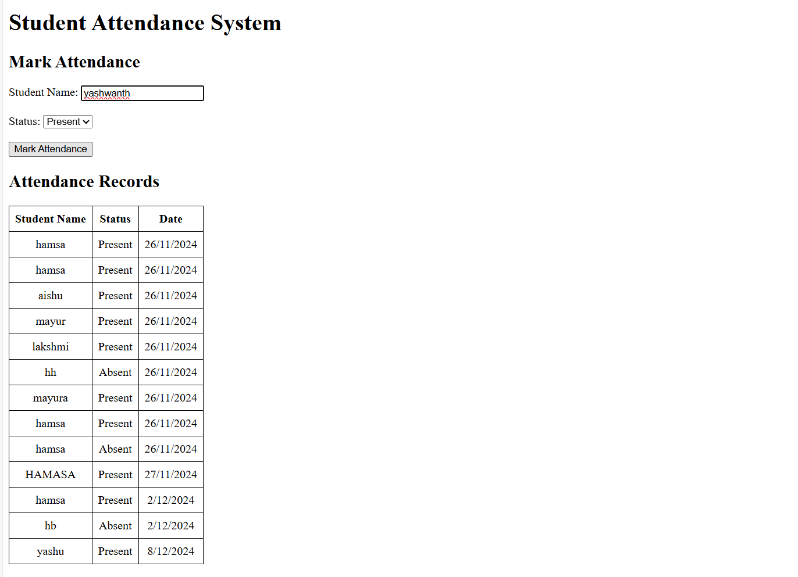
PHP
?php
$servername = "localhost";
$username = "root";
$password = "";
$dbname ="test";
$conn = new mysqli($servername, $username, $password, $dbname);
if ($conn->connect_error) {
die("Connection failed: " . $conn->connect_error);
}
?>
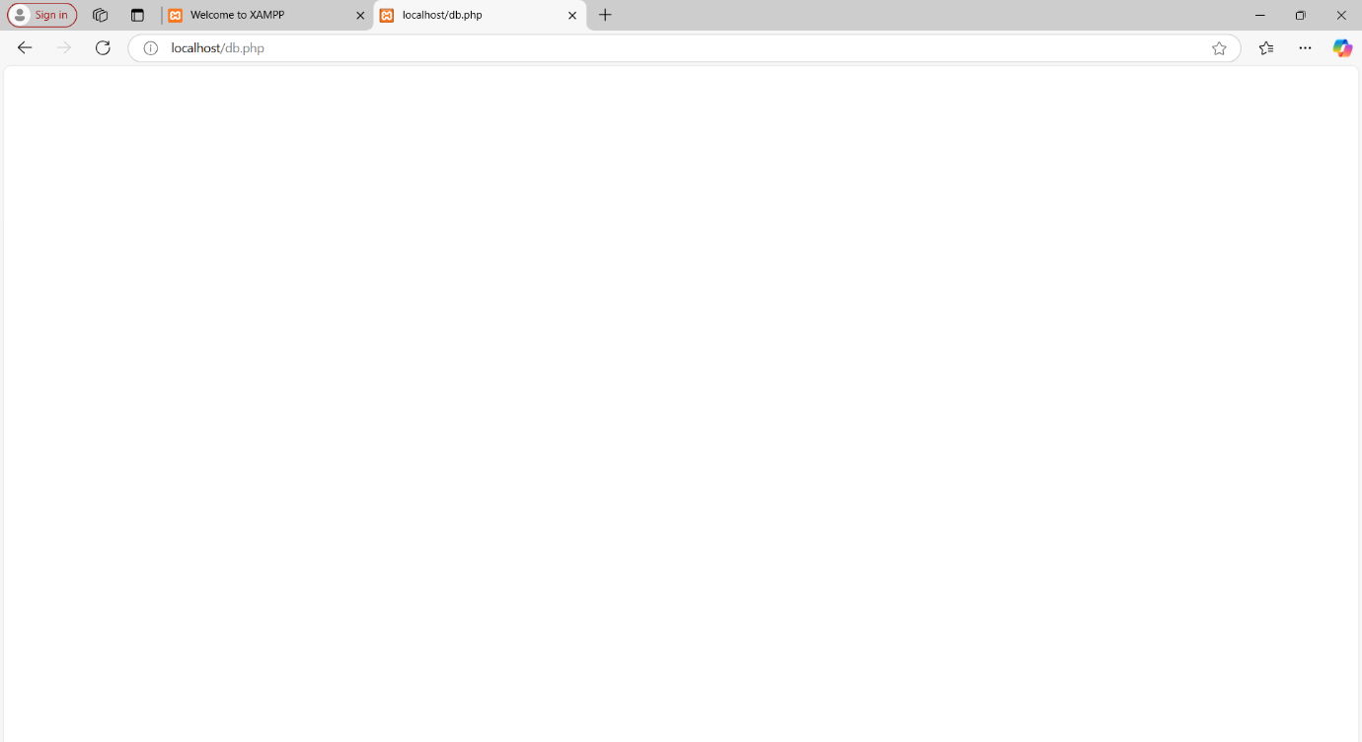

<?php
include 'db.php'; // Ensure this file establishes the $conn MySQLi connection
if ($_SERVER['REQUEST_METHOD'] == 'POST' && isset($_POST['mark_attendance'])) {
$student_id = $_POST['student_id'];
$status = $_POST['status'];
$date = date('Y-m-d');
$stmt = $conn->prepare("SELECT * FROM students1 WHERE student_id = ?");
$stmt->bind_param("i", $student_id);
$stmt->execute();
$stmt->store_result();
if ($stmt->num_rows > 0) {
$stmt->close();
$stmt = $conn->prepare("INSERT INTO attendance1 (student_id, attendance_date, status) VALUES (?, ?, ?)");
$stmt->bind_param("iss", $student_id, $date, $status);
if ($stmt->execute()) {
echo "Attendance marked successfully!";
} else {
echo "Error: " . $stmt->error;
}
$stmt->close();
} else {
echo "Error: Invalid student ID.";
}
}
if ($_SERVER['REQUEST_METHOD'] == 'POST' && isset($_POST['add_student'])) {
$name = $_POST['name'];
$email = $_POST['email'];
$phone = $_POST['phone'];
$department = $_POST['department'];
$stmt = $conn->prepare("INSERT INTO students1 (name, email, phone, department) VALUES (?, ?, ?, ?)");
$stmt->bind_param("ssss", $name, $email, $phone, $department);
if ($stmt->execute()) {
echo "Student added successfully!";
} else {
echo "Error: " . $stmt->error;
}
$stmt->close();
}
$result = $conn->query("SELECT student_id, name FROM students1");
$students1 = [];
if ($result) {
while ($row = $result->fetch_assoc()) {
$students1[] = $row; // Collect rows into an array
}
}
$sql = " SELECT
students1.student_id,
students1.name, COUNT(CASE WHEN attendance1.status = 'Present' THEN 1 END) AS present_days,
COUNT(*) AS total_days,
(COUNT(CASE WHEN attendance1.status = 'Present' THEN 1 END) / COUNT(*)) * 100 AS attendance_percentage
FROM
students1
LEFT JOIN
attendance1
ON
students1.student_id = attendance1.student_id
GROUP BY
students1.student_id
HAVING
attendance_percentage < 75
";
$result = $conn->query($sql);
if ($result->num_rows > 0) {
echo "<script>alert('Some students have low attendance (below 75%)');</script>";
echo "<h3>Students with Low Attendance:</h3>";
echo "<table border='1'>
<tr>
<th>Student ID</th>
<th>Name</th>
<th>Attendance Percentage</th>
</tr>";
while ($row = $result->fetch_assoc()) {
echo "<tr>
<td>{$row['student_id']}</td>
<td>{$row['name']}</td>
<td>" . round($row['attendance_percentage'], 2) . "%</td>
</tr>";
}
echo "</table>";
} else {
echo "<p>All students have attendance above 75%.</p>";
}
?>
<form method="POST">
<input type="text" name="name" placeholder="Name" required>
<input type="text" name="email" placeholder="Email" required>
<input type="text" name="phone" placeholder="Phone" required>
<input type="text" name="department" placeholder="Department" required>
<button type="submit" name="add_student">Add Student</button>
</form>
<form method="POST">
<select name="student_id" required>
<option value="">Select Student</option>
<?php foreach ($students1 as $student): ?>
<option value="<?= htmlspecialchars($student['student_id']); ?>"><?=
htmlspecialchars($student['name']); ?></option>
<?php endforeach; ?>
</select>
<select name="status" required>
<option value="Present">Present</option>
<option value="Absent">Absent</option>
</select>
<button type="submit" name="mark_attendance">Mark Attendance</button>
</form>
